# CERTIFICATE

Project Title: “**LearnHub: Your Center For Skill Enhancement “is** a bona fide work carried out by the following students:

* **TEAM ID:** LTVIP2025TMID54785
* **Madduri Vara Prasad (228B1A0546) (Team Leader)**
* **Nandyala Meghana (228B1A0515) (Team Member)**
* **Phaneendra Gangadi (Team Member)**
* **Velagala Maheswari (Team Member)**

**Date Of Submission:** 30-06-2025

# PROJECT REPORT

* 1. INTRODUCTION
     1. Project Overview
     2. Purpose
  2. IDEATION PHASE
     1. Problem Statement
     2. Empathy Map Canvas
     3. Brainstorming
  3. REQUIREMENT ANALYSIS
     1. Customer Journey map
     2. Solution Requirement
     3. Data Flow Diagram
     4. Technology Stack
  4. PROJECT DESIGN
     1. Problem Solution Fit
     2. Proposed Solution
     3. Solution Architecture
  5. PROJECT PLANNING & SCHEDULING
     1. Project Planning
  6. FUNCTIONAL AND PERFORMANCE TESTING
     1. Performance Testing
  7. RESULTS
     1. Output Screenshots
  8. ADVANTAGES & DISADVANTAGES
  9. CONCLUSION
  10. FUTURE SCOPE
  11. APPENDIX

Source Code Dataset Link

GitHub & Project Demo Link

# 1. INTRODUCTION

**PROJECT OVERVIEW:**

An online learning platform(OLP) is a digital platform that provides a variety of tools and resources to facilitate learning and education over the internet. These platforms have become increasingly popular, especially in recent years, as they offer flexibility and accessibility for learners of all ages and backgrounds. Here are some key features and a description of an online learning platform:

.

→ **User-Friendly Interface:** Online learning platforms typically have an intuitive and user-friendly interface that makes it easy for learners, regardless of their technical proficiency, to navigate and access the content.

→ **Course Management:** Instructors or course creators can upload, organize, and manage course materials. Learners can enroll in courses and track their progress.

→ **Interactivity:** Many platforms include interactive elements like discussion forums, chat rooms, and live webinars, which foster communication and collaboration among learners and instructors.

→ **Certification:** Learners can earn certificates or badges upon completing courses or meeting certain criteria, which can be valuable for employment or further education.

→ **Accessibility:** Content is often accessible on various devices, including computers, tablets, and smartphones, making learning possible from anywhere with an internet connection.

→ **Self-Paced Learning:** Learners can typically access course materials at their own pace. This flexibility allows for learning that fits into individual schedules and preferences.

→ **Payment and Subscription Options**: There may be free courses, but some content may require payment or a subscription. Platforms often offer multiple pricing models.

→ **User Registration:** Sarah, a student interested in learning web development, visits the Online Learning Platform and creates an account. She provides her email and chooses a password.

→ **Browsing Courses:** Upon logging in, Sarah is greeted with a user-friendly interface displaying various courses categorized by topic, difficulty level, and popularity.

→ She navigates through the course catalog, filtering courses by name and category until she finds a "Web Development Fundamentals" course that interests her.

→ **Enrolling in a Course:** Sarah clicks on the course and reads the course description, instructor details, and syllabus. Impressed, she decided to enroll in the course.

→ After enrolling, Sarah can access the course materials, including video lectures, reading materials, and assignments.

→ **Learning Progress:** Sarah starts the course and proceeds through the modules at her own pace. The platform remembers her progress, allowing her to pick up where she left off if she needs to take a break.

→ **Interaction and Support:** Throughout the course, Sarah engages with interactive elements such as discussion forums and live webinars where she can ask questions and interact with the instructor and other learners.

→ **Course Completion and Certification:** After completing all the modules and assignments, Sarah takes the final exam. Upon passing, she receives a digital certificate of completion, which she can download and add to her portfolio.

→ **Paid Courses:** Sarah discovers an advanced web development course that requires payment. She purchases the course using the platform's payment system and gains access to premium content.

→ **Teacher's Role:** Meanwhile, John, an experienced web developer, serves as a teacher on the platform. He creates and uploads new courses on advanced web development topics, adds sections to existing courses, and monitors course enrollments.

→ **Admin Oversight:** The admin oversees the entire platform, monitoring user activity, managing course listings, and ensuring smooth operation. They keep track of enrolled students, handle any issues that arise, and maintain the integrity of the platform.

|  |  |
| --- | --- |
| **2.IDEATION PHASE**   **PROBLEM STATEMENT:**  In many institutions, **skill development and learning resources are scattered**, outdated, or not personalized. Students often face difficulty finding credible, organized content, while educators lack a streamlined tool to deliver courses, track learner engagement, and share multimedia materials..   **EMPATHY MAP CANAVS:**  **Ideation Phase Empathize & Discover** | |
| Date | 19 June 2025 |
| Team ID | LTVIP2025TMID54785 |
| Project Name | **LearnHub: Your Center For Skill Enhancement** |
| Maximum Marks | 4 Marks |
| **Empathy Map Canvas:**  An empathy map is a simple, easy-to-digest visual that captures knowledge about a user’s behaviours and attitudes.  It is a useful tool to helps teams better understand their users.  Creating an effective solution requires understanding the true problem and the person who is experiencing it. The exercise of creating the map helps participants consider things from the user’s perspective along with his or her goals and challenges.  Diagram  Description automatically generated  5 | |

|  |  |  |
| --- | --- | --- |
| → **BRAINSTROMING:**  Ideation Phase Brainstorm & Idea Prioritization Template | | |
| Date | 20 June 2025 |  |
| Team ID | LTVIP2025TMID54785 |  |
| Project Name | **LearnHub: Your Center For Skill Enhancement** |  |
| Maximum Marks | 4 Marks |  |
| Brainstorm & Idea Prioritization Template:  Brainstorming provides a free and open environment that encourages everyone within a team to participate in the creative thinking process that leads to problem solving. Prioritizing volume over value, out-of-the-box ideas are welcome and built upon, and all participants are encouraged to collaborate, helping each other develop a rich amount of creative solutions.  Use this template in your own brainstorming sessions so your team can unleash their imagination and start shaping concepts even if you're not sitting in the same room.  **Step-1: Team Gathering, Collaboration and Select the Problem Statement**  Graphical user interface, application  Description automatically generated  6 | | |

**Step-2: Brainstorm, Idea Listing and Grouping:**

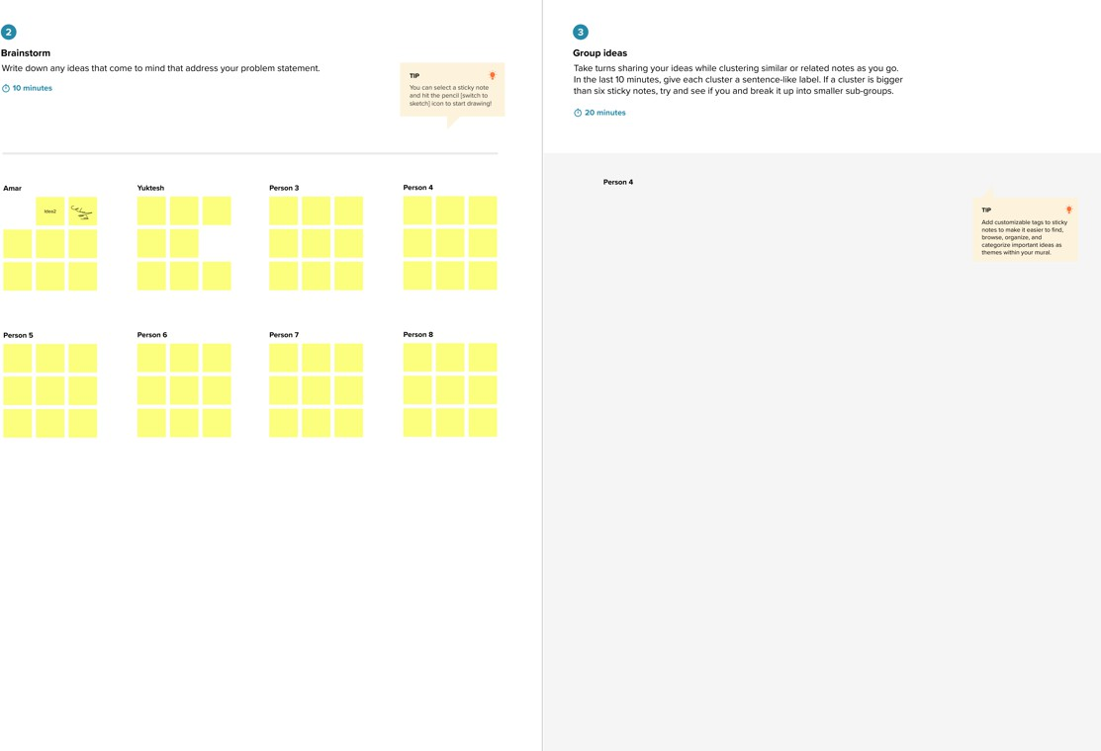

**Step-3: Idea Prioritization**

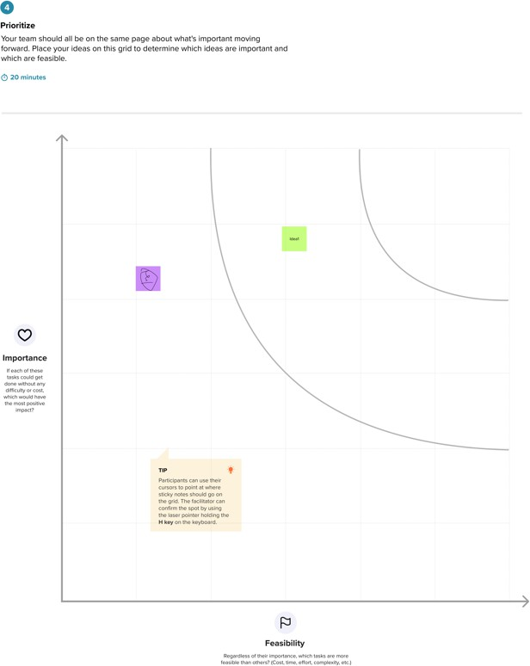

7

|  |  |  |  |  |
| --- | --- | --- | --- | --- |
| **3.REQIREMENT ANALYSIS**   **Customer Journey map:**     **Solution Requirement:**  **Project Design Phase-II**  **Solution Requirements (Functional & Non-functional)**   | | | | |
| Date | | 21 June 2025 | |  |
| Team ID | | LTVIP2025TMID54785 | |  |
| Project Name | | **LearnHub: Your Center For Skill Enhancement** | |  |
| Maximum Marks | | 4 Marks | |  |
| **Functional Requirements:**  Following are the functional requirements of the proposed solution. | | | | |
| FR  No. | Functional Requirement (Epic) | | Sub Requirement (Story / Sub-Task) | |
| FR-1 | User Registration | | Manual registration via a form for students and teachers | |
| FR-2 | User Confirmation | | Upon form submission, users are immediately registered and can log in without approval delay | |
| FR-3 | User Authentication | | Secure login using credentials (email and password) with JWT-based token authentication | |
| 8 | | | | |

|  |  |  |  |  |
| --- | --- | --- | --- | --- |
|  | | | | |
| FR-4 | Role-Based Dashboard | | Users are redirected to role-specific dashboards (Student or Teacher) after login | |
| FR-5 | Course Creation (Teacher) | | Teachers can create new courses with title, description, and multimedia content (videos/images/text) | |
| FR-6 | Course Management | | Teachers can update or delete their created courses | |
| FR-7 | Course Viewing (Student) | | Students can browse all available courses with previews | |
| FR-8 | Course Enrollment (Student) | | Students can enroll in available courses from their dashboard | |
| FR-9 | Content Access | | Enrolled students can view full course content including videos, documents, and images | |
| FR-10 | Progress Tracking | | Students can track their completion status for enrolled courses | |
| FR-11 | Logout | | Users can securely log out, ending the JWT session | |
| **Non-functional Requirements:**  Following are the non-functional requirements of the proposed solution. | | | | |
| **FR**  **No.** | **Non-Functional**  **Requirement** | **Description** | |  |
| NFR- 1 | **Usability** | LearnHub provides a clean, intuitive, and responsive interface using React, allowing both students and teachers to easily navigate and use the system with minimal training. | |  |
| NFR- 2 | **Security** | User data is protected with JWT-based authentication and secure password storage using hashing. Role-based access ensures only authorized users can access respective dashboards and features. | |  |
| NFR- 3 | **Reliability** | The system is designed to function consistently, ensuring users can register, log in, and access content without interruption. Error handling is implemented to catch and log failures. | |  |
| NFR-  4 | **Performance** | Built with Vite and React for fast loading times and smooth transitions. The application is optimized to handle multiple simultaneous users with minimal lag. | |  |
| NFR- 5 | **Availability** | The platform ensures high uptime and can be hosted on cloud services to maintain continuous access for users. Downtime is minimized through proper deployment and monitoring. | |  |
| NFR- 6 | **Scalability** | The architecture allows for future growth in user base and features. Additional components (like quizzes, certificates, payments) can be added without major redesign. | |  |
| → **Data Flow Diagram:**  **Project Design Phase-II Data Flow Diagram & User Stories**  9 | | | | |

|  |  |
| --- | --- |
| Date | 22 June 2025 |
| Team ID | LTVIP2025TMID54785 |
| Project Name | **LearnHub: Your Center For Skill Enhancement** |
| Maximum Marks | 4 Marks |

Data Flow Diagrams:

A Data Flow Diagram (DFD) is a traditional visual representation of the information flows within a system. A neat and clear DFD can depict the right amount of the system requirement graphically. It shows how data enters and leaves the system, what changes the information, and where data is

**Example:**

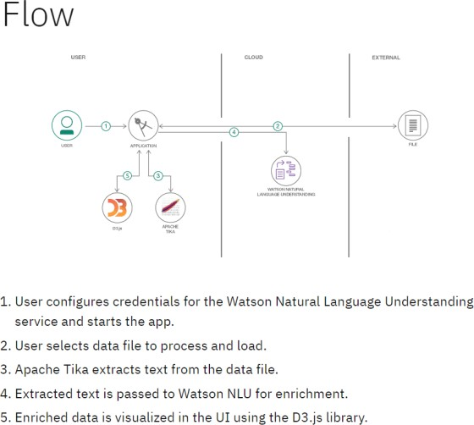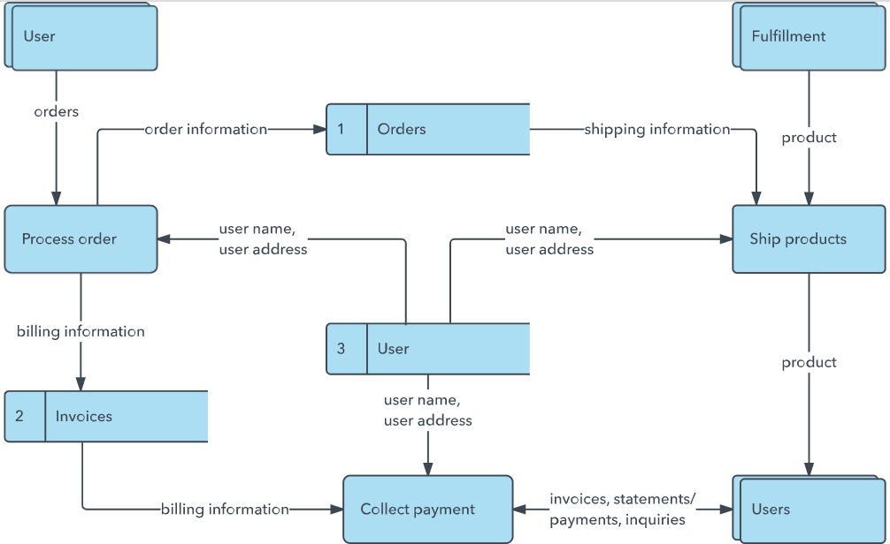

10

|  |  |  |  |  |  |  |  |
| --- | --- | --- | --- | --- | --- | --- | --- |
| **User Stories:** | | | | | | | |
|  | **User Type** | **Functional Requirement** | **User Story**  **No.** | **User Story / Task** | **Acceptance Criteria** | **Priority** | **Release** |
|  | Student | Registration | USN-1 | As a student, I can register via form with email and  password | I can create an account and access my student dashboard | High | Sprint-1 |
|  | Student | Login | USN-2 | As a student, I can log in using my email and  password | I enter valid credentials and log in successfully | High | Sprint-1 |
|  | Student | View Courses | USN-3 | As a student, I can view a list of all available courses | Courses with title, educator, and brief description are  displayed | High | Sprint-1 |
|  | Student | Enroll in Courses | USN-4 | As a student, I can enroll in a course I  am interested in | Course appears in my dashboard and I can  access its content | High | Sprint-1 |
|  | Student | View Course Content | USN-5 | As a student, I can view the full content (video/image/text) of enrolled  courses | All sections of the course are accessible after enrollment | High | Sprint-1 |
|  | Student | Track Progress | USN-6 | As a student, I can track my progress in a course | My progress (completed/incomplete) is updated as I go through course sections | Medium | Sprint-2 |
|  | Teacher | Registration | USN-7 | As a teacher, I can register via form with email and  password | I can create an account and access my teacher dashboard | High | Sprint-1 |
|  | Teacher | Login | USN-8 | As a teacher, I can log in using my email and  password | I can access my dashboard upon successful login | High | Sprint-1 |
|  | Teacher | Create Course | USN-9 | As a teacher, I can create a new course with title  and description | New course is saved and visible in my dashboard | High | Sprint-1 |
|  | Teacher | Add Course Content | USN- 10 | As a teacher, I can add multiple sections (video, image, text) to a  course | Content appears in structured format in course view | High | Sprint-1 |
|  | Teacher | Update/Delete Courses | USN- 11 | As a teacher, I can update or delete  my created | Changes are saved and reflected immediately | Medium | Sprint-2 |
| 11 | | | | | | | |

|  |  |  |  |  |  |  |  |
| --- | --- | --- | --- | --- | --- | --- | --- |
|  | | | | | | | |
|  |  |  |  | courses |  |  |  |
|  | Teacher | View Enrolled Students | USN- 12 | As a teacher, I can view the list of students enrolled  in my course | Enrolled student list is visible for each course | Low | Sprint-2 |
|  | Admin (Optional) | Manage Users | USN- 13 | As an admin, I can view all registered users and their  roles | Full user list is available with filters and role labels | Medium | Sprint-2 |
|  | Admin (Optional) | Manage Courses | USN- 14 | As an admin, I can view all courses created by  teachers | List of courses with details is accessible from admin dashboard | Medium | Sprint-2 |
| 12 | | | | | | | |

→ Technology Stack:

**Project Design Phase-II Technology Stack (Architecture & Stack)**

|  |  |
| --- | --- |
| Date | 22 June 2025 |
| Team ID | LTVIP2025TMID54785 |
| Project Name | **LearnHub: Your Center For Skill Enhancement** |
| Maximum Marks | 4 Marks |

Table 1: Components & Technologies

|  |  |  |  |
| --- | --- | --- | --- |
| **S.No** | **Component** | **Description** | **Technology Used** |
| 1 | User Interface | Web-based UI for students,  teachers, and admin interactions | React.js, HTML,  CSS, JavaScript, Bootstrap |
| 2 | Application Logic –  1 | Handles routing, API calls, course logic, and business  operations | Node.js, Express.js |
| 3 | Application Logic –  2 | Role-based login, user  sessions, and secure access handling | JWT (JSON Web  Token), bcrypt.js |
| 4 | Application Logic –  3 | Chat system between students and teachers/admins *(future*  *enhancement)* | Socket.io *(planned)* |
| 5 | Database | Stores users, courses, enrollments, roles, and  learning progress | MongoDB |
| 6 | Cloud Database | Cloud-hosted scalable NoSQL storage | MongoDB Atlas |
| 7 | File Storage | For uploading media content (course images/videos/screenshots)  *(optional)* | Local filesystem or Cloudinary *(optional)* |
| 8 | External API – 1 | Location/IP tracking  features *(future enhancement)* | IPInfo API  *(optional)* |
| 9 | External API – 2 | Not used in the current  version | — |
| 10 | Machine Learning  Model | Not applicable in this  version | — |
| 11 | Infrastructure | Hosting frontend and | Render (Backend), |

|  |  |  |  |
| --- | --- | --- | --- |
|  |  | backend on cloud platforms | Vercel / Netlify  (Frontend) |

Table 2: Application Characteristics

|  |  |  |  |
| --- | --- | --- | --- |
| **S.No** | **Characteristics** | **Description** | **Technology Used** |
| 1 | Open-Source Frameworks | Core frameworks and libraries used in full- stack app  development | React.js, Node.js, Express.js, MongoDB |
| 2 | Security Implementations | Implements secure user access, encrypted credentials, and token-  based sessions | bcrypt.js, JWT, Helmet (Express middleware) |
| 3 | Scalable Architecture | Modular, layered design with separation of concerns (frontend, backend, database) | MERN Stack (3-tier architecture) |
| 4 | Availability | Deployed on cloud infrastructure ensuring high uptime and global  accessibility | Render, MongoDB Atlas |
| 5 | Performance | Fast user interactions, asynchronous API calls, and optimized data handling | React, Axios, MongoDB |

|  |  |  |
| --- | --- | --- |
| **4. PROJECT DESIGN**   Problem Solution Fit:  **Project Design Phase Problem – Solution Fit Template**   | | |
| Date | 23 June 2025 |  |
| Team ID | LTVIP2025TMID54785 |
| Project Name | **LearnHub: Your Center For Skill Enhancement** |
| Maximum Marks | 2 Marks |
| 1. **The Problem**   In many educational institutions and skill development environments:   * + Learning content is often scattered, outdated, or not organized in a structured format.   + Students lack clarity regarding their learning progress and find it difficult to access consistent resources.   + Teachers do not have an easy-to-use platform to create, manage, and deliver digital courses effectively.   + Existing systems frequently lack media support, interactivity, and user-friendly dashboards for students and teachers.   + There is no centralized platform that connects learners and educators for streamlined course management and engagement.  1. **The Solution – LearnHub**   **LearnHub** is a web-based platform designed to provide a centralized solution for both students and teachers by offering the following:   * + Teachers can create comprehensive courses with video lectures, images, and supporting text content.   + Students can browse, enroll in, and access multiple skill-based courses from a single dashboard.   + The system features role-based dashboards to separate functionalities for students and teachers.   + Students can track their learning progress across different course sections.   + Built using Vite and React, the platform ensures fast loading, responsiveness, and a smooth user experience.  1. **Behavioral Insights**    * Students are already familiar with web and mobile learning applications and prefer digital access to courses.    * They expect a transparent and self-paced learning environment that allows them to monitor their progress.    * Teachers prefer a structured system that allows them to easily upload, organize, and manage course materials.    * Both users value a modern and intuitive interface that simplifies learning and teaching interactions.   15 | | |

|  |  |  |
| --- | --- | --- |
| **4. Fit Justification** | | |
| **Element** | **Observation / Challenge** |  |
| Student Confusion | Students are unsure about course structure and progress |
| Limited Access to Content | Students struggle to find or access organized learning resources |
| Teacher Inconvenience | Teachers lack a simple tool to create and manage course material |
| Role Confusion | No separation of features for teachers and students |
| Lack of Engagement | No system for learners to track achievements or status |
| Scalability Issues | Manual or static content delivery limits expansion |
| 1. **Benefits**    * **Faster Adoption**: The platform offers a simple, web-based user interface with minimal setup, enabling quick onboarding for both students and teachers.    * **Improved User Satisfaction**: By providing transparency in course access and real-time progress tracking, the platform enhances trust and engagement among users.    * **Scalable Architecture**: The modular and role-based system design supports future growth, addressing the evolving needs of students, educators, and administrators.    * **Future-Ready Foundation**: LearnHub is built to support future enhancements such as real-time chat between students and teachers, mobile app integration, and advanced content analytics.   Calendar  Description automatically generated  16 | | |

|  |  |  |  |  |  |
| --- | --- | --- | --- | --- | --- |
| → Proposed Solution:  **Project Design Phase Proposed Solution Template** | | | | | |
| Date | | | 23 June 2025 | |  |
| Team ID | | | LTVIP2025TMID54785 | |
| Project Name | | | **LearnHub: Your Center For Skill Enhancement** | |
| Maximum Marks | | | 2 Marks | |
|  | | | | | |
| **S.No.** | | **Parameter** | | **Description** |  |
| 1. 1. | | **Problem Statement (Problem to be solved)** | | In many educational and skill-building environments, students face difficulty accessing structured, engaging, and centralized learning resources. Teachers lack an intuitive platform to create and manage courses. Most traditional systems are either manual or disconnected, lacking transparency, progress tracking, and proper learner-educator  interaction. |
| 2. | 2. | **Idea / Solution Description** | | LearnHub is a web-based course creation and enrollment platform that bridges the gap between students and teachers. It allows teachers to create multimedia-rich courses and students to enroll, view, and track their progress. The platform includes role-based dashboards for  Teachers and Students, offering a clean and responsive experience built with the MERN stack (MongoDB, Express.js, React.js, Node.js). |
| 3. | 3. | **Novelty / Uniqueness** | | - Role-based dashboards for tailored user experience - Simple, modern interface using Vite + React - Modular MERN stack architecture ensures scalability and maintainability - Future scope includes live teacher- student chat, mobile app support, certification system, and content  analytics |
| 4. | 4. | **Social Impact / Customer Satisfaction** | | LearnHub enhances access to quality learning by offering a centralized platform for self-paced education. Students benefit from clear course structures and progress tracking, while teachers can easily distribute knowledge. This results in increased student engagement, better skill  development, and improved teacher productivity. |
| 5. | 5. | **Business Model (Revenue Model)** | | Though currently an academic/non-commercial project, LearnHub can adopt the following models: • **SaaS Platform:** Subscription-based access for institutions or training centers • **Course Marketplace:** Allow  educators to sell their courses with a revenue share • **Premium Features:** Paid features like certifications, analytics, quiz modules, and  LMS integrations |
| 6. | 6. | **Scalability of the Solution** | | LearnHub follows a scalable three-tier architecture (frontend, backend, database) and is deployable on cloud platforms like Vercel, Render, or AWS. It supports multiple user roles, concurrent sessions, and can be extended with additional features such as mobile app integration, multi-  language support, real-time chat, and more. |
| 17 | | | | | |

→ Solution Architecture:

**Project Design Phase Solution Architecture**

Date Team ID

Project Name Maximum Marks

24 June 2025

LTVIP2025TMID54785

**LearnHub: Your Center For Skill Enhancement**

4 Marks

* Overview:

The solution architecture of LearnHub is designed to provide a modular, scalable, and user- centric platform for digital learning. It connects teachers and students through a responsive web interface and enables seamless course creation, enrollment, and content access. The system is built using the MERN stack (MongoDB, Express.js, React.js, Node.js) and follows modern web development practices for performance and maintainability.

* Goals of the Architecture:

Utilize modern technologies to simplify course distribution and learning. Structure the system into clear layers for frontend, backend, and database. Ensure secure and role-based access for students and teachers.

Enable scalability for future enhancements like mobile apps, chat, and certification. Maintain clean separation of concerns for easy development and deployment.

* Architecture Layers:

1. Presentation Layer (Frontend)

Technology: React.js (with Vite), HTML, CSS, Bootstrap

Purpose: Interface for students and teachers to interact with the system. Features:

Role-based dashboards (Student, Teacher)

Student: View courses, enroll, access content, track progress Teacher: Create courses, upload materials, manage students Responsive design for web access

1. Application Layer (Backend) Technology: Node.js, Express.js

Purpose: Handles business logic, API routing, user session handling, and course operations. Key APIs:

18

|  |  |
| --- | --- |
| User registration and login (JWT-authenticated) Role validation (Student vs. Teacher)  Course creation and section management (video/image/text) Enrollment tracking and progress update   1. Data Layer (Database)   Technology: MongoDB (via MongoDB Atlas – Cloud DB)  Purpose: Stores users, courses, enrollments, sections, and learning progress. Security:  Passwords encrypted using bcrypt.js  JWT tokens for secure session management   * + Supporting Services:   Authentication: JSON Web Tokens (JWT), bcrypt.js for secure password handling Deployment:  Frontend: Vercel or Netlify Backend: Render or Railway   * + Optional / Future Integrations:   Real-Time Chat: Socket.io for live doubt clearance sessions (future)  Cloud Storage: Cloudinary or Firebase for uploading videos, documents, and images Certification Module: Auto-generated certificates after course completion Analytics: Engagement and completion rate tracking for students   Development Phases: | |
| Sprint | Scope |
| Sprint  1 | User registration/login, role-based dashboards, course creation, enrollment |
| Sprint  2 | Course content management (sections), progress tracking, view enrolled  students |
| Sprint  3 | Future scope: chat feature, analytics, certificate generation, mobile app |
| 19 | |

|  |  |
| --- | --- |
|  |  |
|  |  |
|  |  |
|  |  |

|  |  |  |  |  |  |  |
| --- | --- | --- | --- | --- | --- | --- |
| **5. PROJECT PLANNING & SCHEDULING**   Project Planning:  **Project Planning Phase**  **Project Planning Template (Product Backlog, Sprint Planning, Stories, Story points)**  Date 25 June 2025  Team ID LTVIP2025TMID54785  Project Name **LearnHub: Your Center For Skill Enhancement**  Maximum Marks 5 Marks  **1. Product Backlog and Sprint Schedule** | | | | | | |
| **Sprint** | **Functional Requiremen t (Epic)** | **User Story Numbe r** | **User Story / Task** | **Story Point s** | **Priority** | **Team Member s** |
| Sprint  -1 | Registration | USN-1 | As a user, I can register for the application by entering my email, password, and confirming my  password. | 2 | High |  |
| Sprint  -1 | Registration Confirmation | USN-2 | As a user, I will receive a confirmatio n email once I have registered for the  application. | 1 | High |  |
| Sprint  -1 | Social Registration (Gmail) | USN-4 | As a user, I can register for the application through Gmail. | 2 | Mediu m |  |
| Sprint  -1 | Login | USN-5 | As a user, I  can log into the | 1 | High |  |
| 20 | | | | | | |

|  |  |  |  |  |  |  |  |  |  |  |
| --- | --- | --- | --- | --- | --- | --- | --- | --- | --- | --- |
|  | | | | | | | | | | |
|  |  | | |  | application by entering  email and password. | |  | |  |  |
| Sprint  -2 | Social Registration Restriction | | | USN-3 | As a user, I can’t register for the application through  Facebook. | | 2 | | Low |  |
| **2. Project Tracker, Velocity & Burndown Chart:** | | | | | | | | | | |
| **Sprint** | | **Total Story Points** | **Duration** | | **Sprint Start Date** | **Sprint End Date (Planned)** | | **Story Points Completed (as on Planned**  **End Date)** | | **Sprint Release Date (Actual)** |
| Sprint-1 | | 20 | 6 Days | | 20 June  2025 | 25 June  2025 | | 20 | | 25 June  2025 |
| Sprint-2 | | 20 | 6 Days | | 26 June  2025 | 01 July 2025 | | *Pending / To be updated* | | *Pending* |
| Sprint-3 | | 20 | 6 Days | | 02 July 2025 | 07 July 2025 | | *Pending / To be updated* | | *Pending* |
| Sprint-4 | | 20 | 6 Days | | 08 July 2025 | 13 July 2025 | | *Pending / Work planned between 19*  *to 30 June* | | *Pending* |
| 1. **Velocity Calculation**    * To estimate delivery timelines and monitor team performance, **velocity** is calculated based on the number of story points completed in a sprint.   Formula:  Average Velocity (AV) = Total Story Points / Sprint Duration Example Calculation:   * Sprint Duration: 10 days * Total Story Points Completed: 20   Average Velocity = 20 / 10 = 2 story points per day  21 | | | | | | | | | | |

|  |  |  |
| --- | --- | --- |
| **6. FUNCTIONAL AND PERFORMANCE TESTING**   Performance Testing:  **User Acceptance Testing (UAT)** | | |
| Date | 26 June 2025 |  |
| Team ID | LTVIP2025TMID54785 |  |
| Project Name | **LearnHub: Your Center For Skill Enhancement** |  |
| Maximum Marks | 4 Marks |  |
| * **Project Details**:   Project Name: LearnHub: Your Center for Skill Enhancement  Project Description: *LearnHub* is a web-based learning management platform that allows teachers to create structured, multimedia-rich courses and enables students to enroll, learn, and track progress. It supports role-based dashboards for Students and Teachers and includes authentication, progress tracking, and content management features.  Project Version: 1.0  Testing Period: 26 June 2025 to 27 June 2025   * **Testing Scope:**   + Features and Functionalities to be Tested   + User Registration (via form and Gmail)   + Secure Login with JWT authentication   + Role-Based Dashboards (Student, Teacher)   + Course Creation by Teacher   + Course Enrollment by Student   + Course Content Viewing and Progress Tracking   + Email Notification on Registration (if applicable)   + Access Control and Role Validation   + Backend API integration and data flow   + User Stories / Requirements to be Tested   + USN-1 to USN-5 from the Product Backlog   + Registration via form and Gmail login (OAuth)   + Login with role-based redirection   + Teacher can create and manage courses   + Student can enroll and track learning progress * **Testing Environment:** * URL/Location: [http://localhost:5173](http://localhost:5173/) * Backend: [http://localhost:5000](http://localhost:5000/)   Example:  10 | | |

|  |  |  |  |  |  |  |  |  |  |  |  |
| --- | --- | --- | --- | --- | --- | --- | --- | --- | --- | --- | --- |
|  | | | | | | | | | | | |
| Role | | | Email | | | | | Password | | |  |
| Student | | | [testuser@gmail.com](mailto:testuser@gmail.com) | | | | | 123456 | | |
| Teacher | | | [teacher1@gmail.com](mailto:teacher1@gmail.com) | | | | | 123456 | | |
| Admin* | | | [admin@gmail.com](mailto:admin@gmail.com) | | | | | admin123 | | |
| **Test Cases** | | | | | | | | | | | |
| **Test Case**  **ID** | | **Test Scenario** | **Test Steps** | | **Expected Result** | | | | **Actual Result** | **Pass/Fail** | |
| TC- 001 | | User Registration | 1. Open Register Form2. Enter email and password3. Submit | | User account should be created and redirect to dashboard | | | | User registered successfully | Pass | |
| TC- 002 | | Admin assigns complaint to  agent | 1. Admin logs in2. Views unassigned complaints3.  Assigns to agent | | Complaint status updates in agent  dashboard | | | | Complaint correctly  assigned | Pass | |
| TC- 003 | | Agent updates complaint status | 1. Agent logs in2. Views assigned complaint3.  Changes status | | Status updated for customer view | | | | Customer sees updated status | Pass | |
| TC- 004 | | Invalid login | 1. Go to login2. Enter wrong credentials3.  Submit | | Login should fail with error message | | | | Error message shown | Pass | |
| TC- 005 | | Complaint Tracking | 1. Customer logs in2. Clicks "View Complaints" | | Complaint list should appear | | | | Complaint history  displayed | Pass | |
| **Bug Tracking** | | | | | | | | | | | |
| **Bug**  **ID** | **Bug Description** | | | **Steps to Reproduce** | | **Severity** | **Status** | | **Additional Feedback** | | |
| BG- 001 | OTP Email not received on registration | | | 1. Fill registration form2. Submit3. No email received | | Medium | Open | | Check email service configuration or SMTP logs | | |
| BG- 002 | Gmail login error | | | 1. Click "Login with Gmail"2. Redirects with  error message | | High | In Progress | | Validate Google OAuth credentials and callback  URL | | |
| BG- 003 | Admin dashboard slow to load | | | 1. Login as Admin2. Navigate to dashboard | | Low | Closed | | Fixed with optimized API response | | |
| 10 | | | | | | | | | | | |

**Sign-Off:**

* **Tester Name**: Meghana
* **Date**: 30 June 2025
* **Signature:** Meghana

Notes

* All test cases covered positive and negative scenarios.
* Bugs logged with steps, severity, and current status.
* Project is ready for deployment, pending final sign-off from the project manager and product owner.

.

# RESULTS

* **OUTPUT SCREENSHOTS:**

**Project Implementation:**

On completing the development part, we then run the application one last time to verify all the functionalities and look for any bugs in it. The user interface of the application looks a bit like the one’s provided below.

* **LANDING PAGE:**



* + **LOGIN PAGE:**

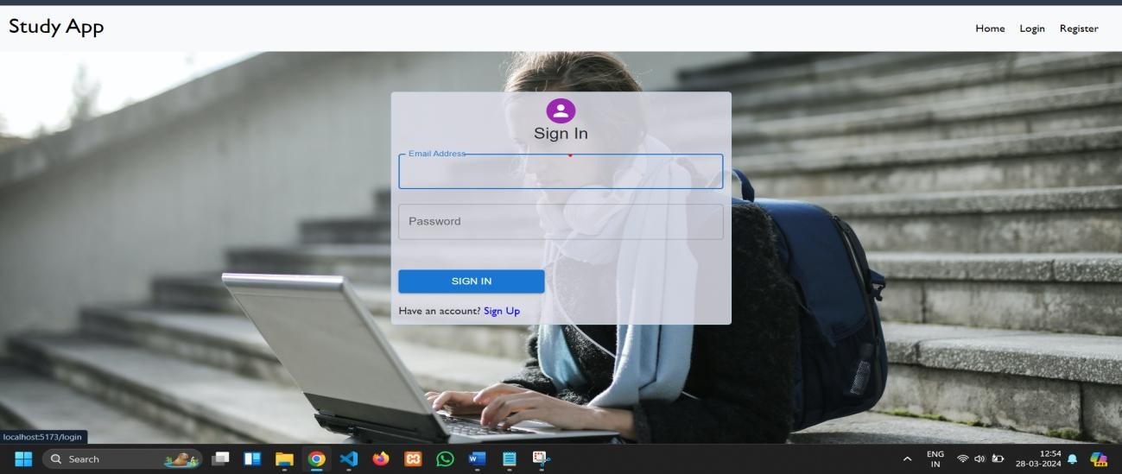

* + **REGISTRATION PAGE:**

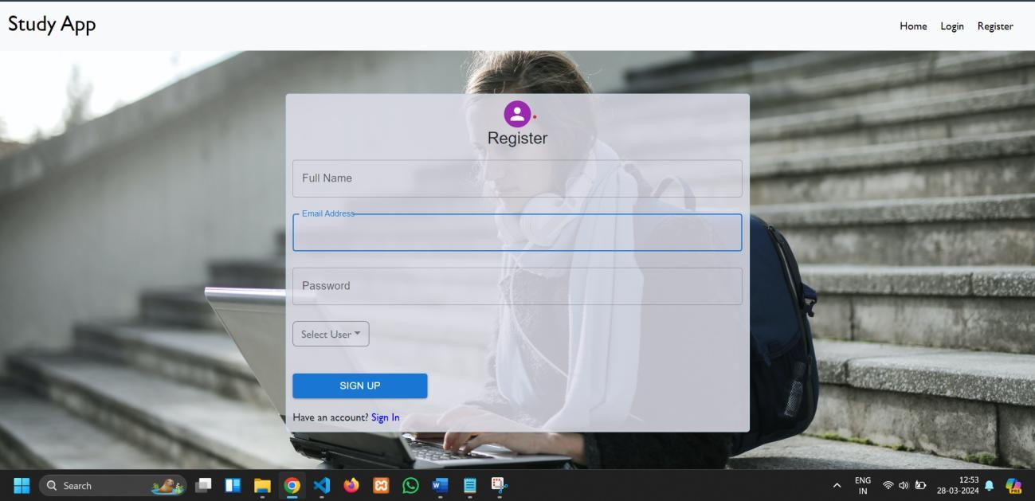

* + **COURSES PAGE:**

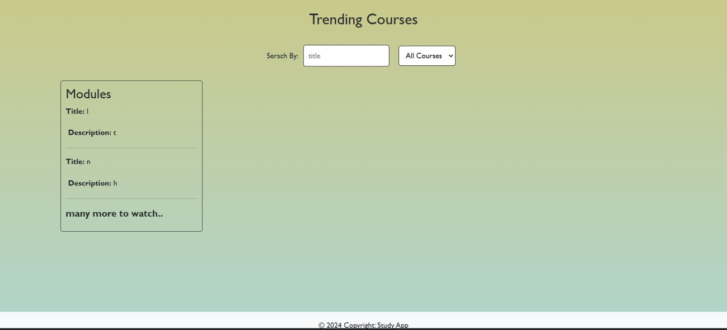

* + **ADMIN DASHBOARD:**

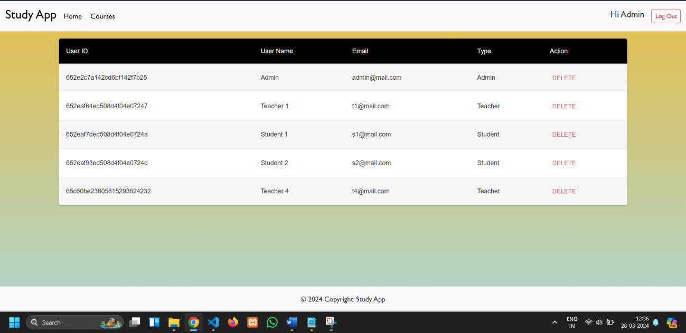

* + **TEACHER DASHBOARD:**

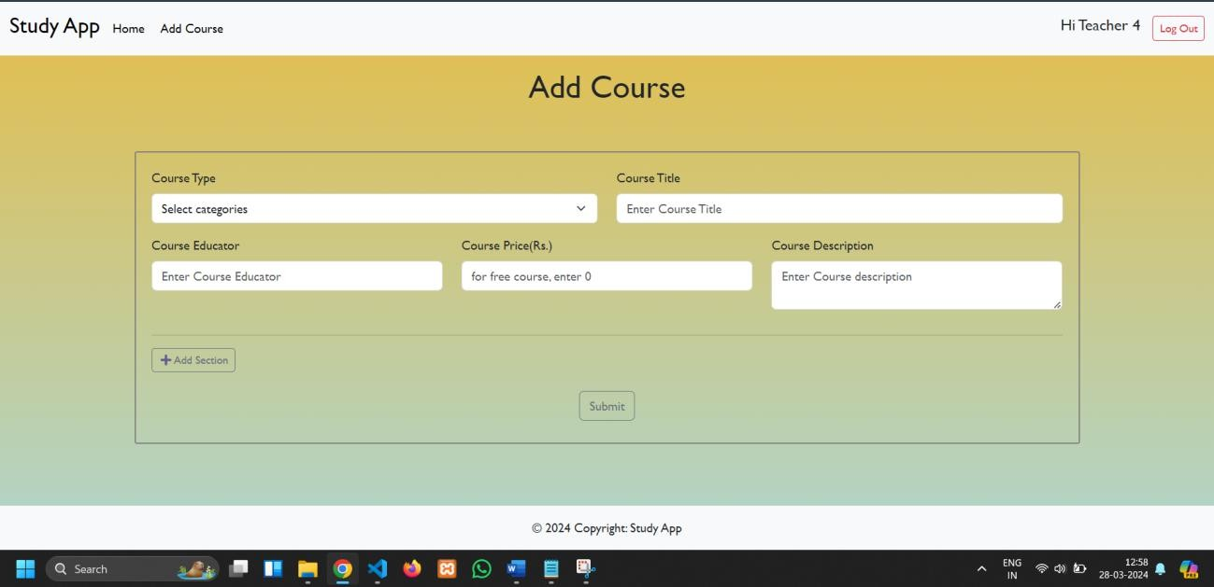

* + **STUDENT DASHBOARD:**

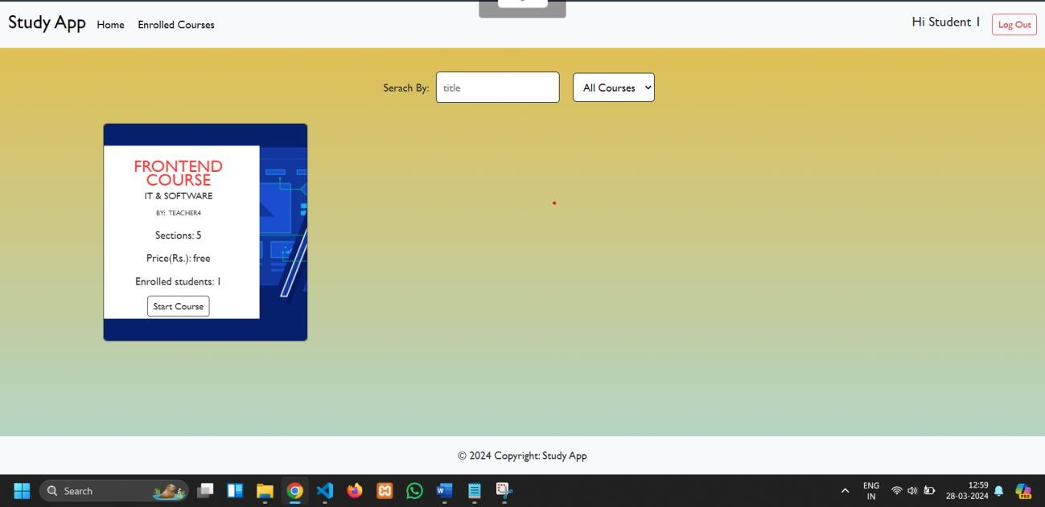

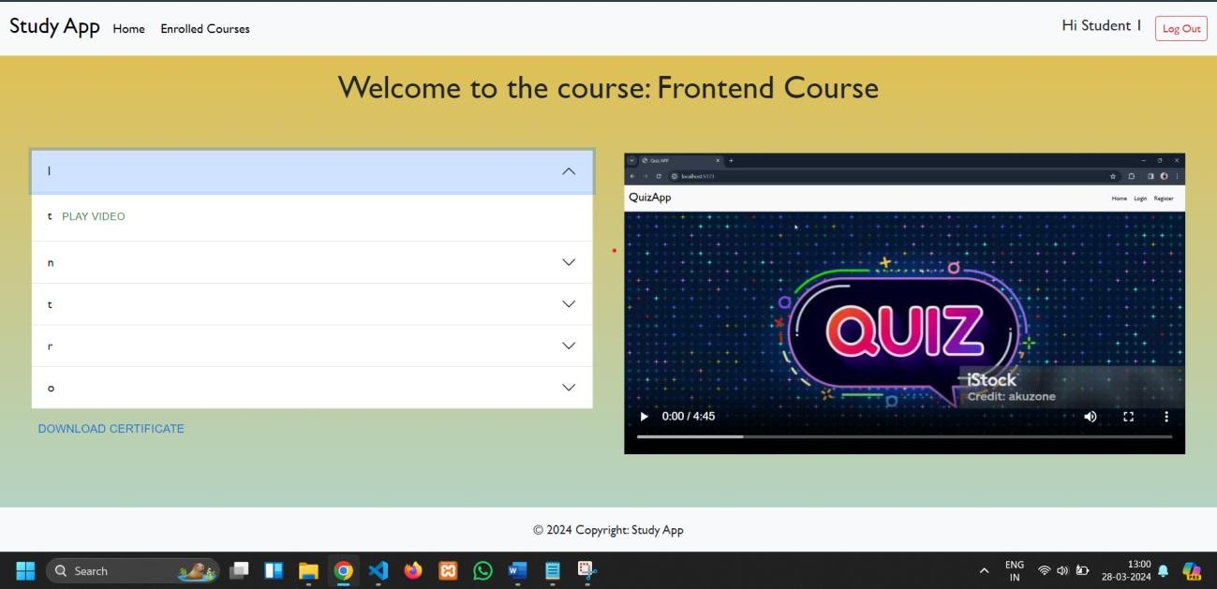

# ADVANTAGES AND DISADVANTAGES

**Advantages:**

1. User-Friendly Interface

The platform offers a clean and intuitive interface built with React and Vite, ensuring smooth navigation for both students and teachers.

1. Role-Based Access Control

Separate dashboards and functionalities for Students and Teachers enhance user experience and maintain access control based on roles.

1. Centralized Learning Platform

All courses, enrollments, and progress data are managed in one place, making the learning process organized and efficient.

1. Progress Tracking

Students can track their course progress in real-time, encouraging self-paced learning and improving motivation.

1. Scalable Architecture

Built using the MERN stack, LearnHub is modular and can be easily scaled to accommodate more users, courses, and institutions.

1. Cloud Integration

Supports deployment on platforms like Vercel (frontend) and Render (backend), with cloud database support via MongoDB Atlas to ensure high availability.

1. Improved Learning Outcomes

Teachers can create multimedia-rich content (videos, images, text), making learning more engaging and accessible.

**Disadvantages:**

1. No Offline Support

The platform requires an internet connection; students cannot access courses or track progress offline.

1. Lack of Real-Time Interaction

The current version does not support live chat or real-time doubt clearance between students and teachers (planned in future versions).

1. Limited Third-Party Integration

Issues may arise with Google OAuth (Gmail login) if misconfigured or if API limits are exceeded.

1. Basic Analytics

There is no detailed reporting or analytics module yet for tracking student performance or engagement patterns.

1. Email Notifications Dependency

OTP or confirmation emails may fail if mail services (SMTP or APIs) are misconfigured or throttled.

# CONCLUSION

**LearnHub** is a full-stack web application developed to streamline and digitize the course creation and enrollment process for educational and skill-development environments. The platform provides an efficient, user-friendly, and organized learning environment where **teachers can create multimedia-rich courses** and **students can enroll, track their progress, and engage with content** seamlessly.

The project is built using the **MERN stack (MongoDB, Express.js, React.js with Vite, and Node.js)**, which offers a modern, modular, and scalable architecture. With **role-based dashboards** tailored for **students and teachers**, LearnHub ensures that course management, learning, and progress tracking are conducted in a structured, accessible, and secure way.

The platform successfully addresses key educational challenges such as:

* Eliminating traditional, unstructured learning processes by digitizing course access and progress tracking.
* Providing centralized access to learning content with real-time visibility into enrolled course status.
* Enabling teachers to independently create, manage, and deliver learning material without technical complexity.
* Empowering students to learn at their own pace while monitoring their achievements.

This system was developed as part of a collaborative internship under **SmartInternz**, allowing the team to engage in **hands-on full-stack development**, apply **agile project planning**, and gain real-world experience in building scalable educational platforms.

By fulfilling the key functional and non-functional requirements — including usability, scalability, and security — **LearnHub** establishes a strong foundation as a **Minimum Viable Product (MVP)**. It is ready for testing in real educational scenarios and demonstrates the capability to transform current challenges in education into practical, tech-driven solutions using industry-standard tools and best practices.

# FUTURE SCOPE

To improve the learning experience and extend platform capabilities, the following enhancements are planned for future versions of LearnHub:

1. Mobile App Integration
   * Develop native Android and iOS applications to allow students and teachers to access courses, dashboards, and content on mobile devices.
   * Provide offline learning features and push notifications for deadlines or updates.
2. Real-Time Chat & Notifications
   * Integrate Socket.IO for live communication between students and teachers.
   * Add real-time notifications for assignment updates, new course releases, and announcements.
3. AI-Powered Course Recommendation
   * Implement machine learning algorithms to suggest personalized courses to students based on their interests, learning history, or enrolled categories.
4. Multilingual Support
   * Introduce multiple language options in the user interface to support learners from different regions and backgrounds.
   * Allow course creators to upload content in various languages.
5. Analytics Dashboard
   * Equip teachers with visual insights into student engagement, course completion rates, and feedback.
   * Allow students to view their own learning analytics and progress charts.
6. Feedback and Rating System
   * Enable students to provide ratings and reviews for courses and instructors after completion.
   * Help teachers improve course quality based on direct learner feedback.
7. Offline Learning Mode
   * Allow students to download course content for offline access, especially in low- connectivity areas.
   * Sync learning progress once reconnected to the internet.

## Running the Application:

1. FRONTEND:
   * To run the **React frontend**-
     + Open terminal and navigate to the frontend folder:



* + - Install dependencies:

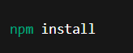

* + - Start the frontend:

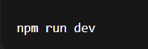

* + - Open browser and visit:

[http://localhost:5173](http://localhost:5173/)

1. BACKEND:
   * To run the **Node.js + Express backend**:
     + Open another terminal and navigate to the backend folder:



* + - Install dependencies:

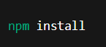

* + - Start the backend server:



* + - Server runs at: [http://localhost:8000](http://localhost:8000/)

## APPENDIX

* + Video Demo Link:

<https://drive.google.com/file/d/1ehubxqoLt0Jc3J71MoKl7zR-WagaS3jy/view>

* + Project Links:

<https://drive.google.com/drive/folders/1d7N-lwCb5QvT7ERs9AeqnU_4mmaSCNNv>

* + Drive Link:

<https://drive.google.com/drive/folders/1d7N-lwCb5QvT7ERs9AeqnU_4mmaSCNNv>

* Git Hub Link:

<https://github.com/Meghana-m20/LearnHub-Online_Learning_Platform_using_MERN/tree/main>